GEVERS AIRCRAFT, INC.
GENESIS

Gevers Aircraft, Inc.
PO Box 430
Brownsburg, Indiana 46112 USA
317-852-2735
INTRODUCTION
The only high performance aircraft that can takeoff and land on snow, water, and hard surface! Unique designs of Multipurpose Landing Gear, Telescopic Wing, and Interconnected Propeller system provide increased utility, performance, and safety.
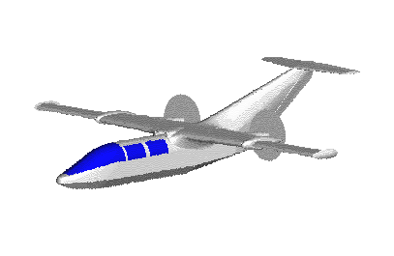
The GENESIS is a twin engine six-seat 'triphibious' aircraft designed for unprecedented speed, utility, safety, and ruggedness. The landing gear enables the aircraft to takeoff and land in water, snow, hard surface, and sod or undeveloped runways without changing gear components and is completely retractable. All three of the aircraft's landing configurations are selectable by the pilot while in flight. The new telescopic wing design gives the aircraft a fast cruise speed of 280 mph while maintaining Short Take Off and Landing (STOL) characteristics for short and rough field conditions on undeveloped and developed airstrips (stall speed 63 mph). Range is also increased to over 2,000 miles. The durable structure gives the aircraft aerobatic capabilities and a useful load of 2,400 lbs (1091 kgs). The innovative propulsion system of the aircraft links both propellers to both engines so power is still provided to both propellers during an engine failure, which greatly increases safety. Patents have been issued and construction is beginning on the prototype aircraft. Preparations are being made for production under FAR Part 23 certification. Investors are being sought to expedite construction of the aircraft.
A new standard in safety, utility, and performance.
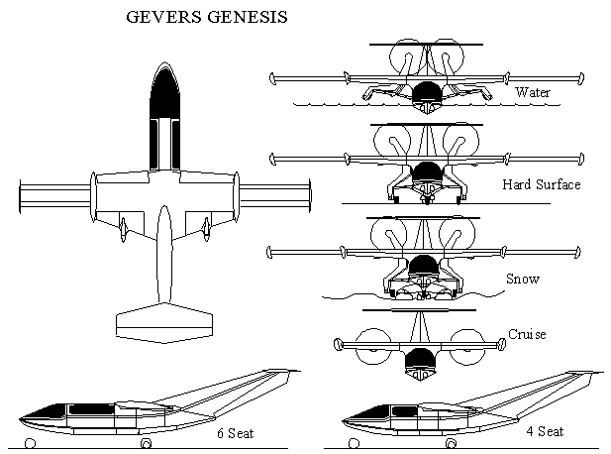

The Genesis is a safe, widely useful - yet high performance - family of aircraft that can operate from clear and snow covered ground bases and from the water.
Primary accomplishments of this design are:
•Multi-purpose landing gear allowing access to airstrips of any terrain; Hard surface, Water, Snow, Intermittent snow and dry surface.
•Twin engine reliability with single engine simplicity and safety by linking both props to both engines through a common gearbox.
•Greatly improve performance over conventional designs by using a unique telescopic wing.
•Higher cruise speed than any other aircraft of similar HP while maintaining STOL characteristics.
•Modular and interchangeable subassemblies for manufacturing and construction simplicity.
•Capable of simulating a variety of aircraft configurations with a single rugged aircraft for use as a training aircraft.
•Vehicle for airfoil testing.
•Aerobatic strength capability.
•Inherent safety in the air and on the ground.

Three unique systems were developed in order to accomplish all of the above. The three systems, (interconnected propellers, multi-purpose landing gear, and telescopic wing), are capable of functioning independently on an aircraft or used in any combination. These three systems are brought together with great synergy in a single design called the GENESIS.
A six-place twin engine configuration proof-of-concept aircraft is currently beginning construction, a four-place version with smaller engines is planned along with a wider body cargo version. Larger variations including special duty configurations are under investigation.
Although the aircraft incorporates several innovative mechanical designs that give it unprecedented capabilities and performance, the aerodynamics, construction materials, and construction techniques are conventional, (riveted aluminum structure).
Patents have been issued in the US and several other countries.
MULTI-CONFIGURATION LANDING GEAR (TRIPHIBIOUS)
Convertible in flight between wheels, skis, and amphibious hull.
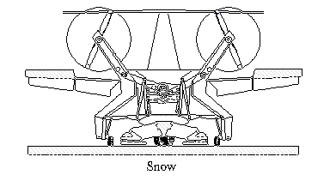
The ability to takeoff & land on hard surface, water, snow, and intermittent snow covered runways gives the Genesis high utility capabilities. All landing configurations are selectable from the cockpit in flight without the need to change gear components on the ground.
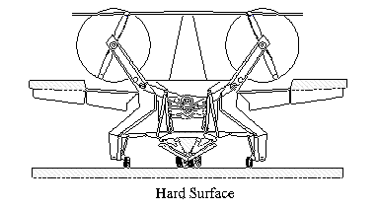
Description:
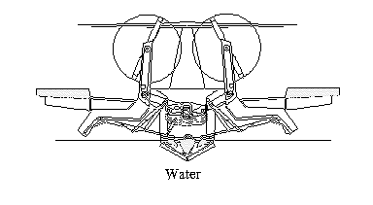
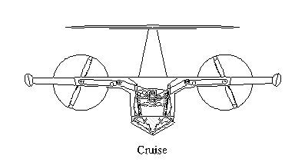
The main landing gear is a dual wheel assembly under the center rear of the fuselage. Large diameter tires allow for operation from undeveloped or developed airstrips. Two smaller diameter castoring outrigger wheels are attached to the bottom of the propeller mount arms. The propeller mount arms (see the Interconnected Propeller Drive page on this site) also serve as stabilizing outriggers in the seaplane configuration.
In cruise with the gear retracted, the ski surfaces are flush with the hull and become the gear doors making an efficient retractable ski-plane. This makes a relatively inexpensive and easily replaced skid in the event of a gear up landing on a hard surface. The absence of gear doors simplifies the design and eliminates the gear extension speed limitation, which allows the gear to also act as a speed brake if desired. The stabilizing pontoons (outriggers) also completely retract in such a way as to fill in the area behind the step providing an aerodynamically efficient amphibian in cruise.
When landing on water, the main skis remain retracted and form the aft hull forward of the "step". Since the gear is shock mounted even when retracted, the skis and the hull step are also shock mounted. This feature absorbs water-landing impact. During water landing the outriggers are fully extended (raised) so they do not drag in the water. After landing, the outriggers can be partially retracted down into the water, which stabilizes and levels the plane for taxiing. The main gear components are made of buoyant structures that constitute sealed compartments.
For hard surface and snow landings the extremely strong tire/ski combination is extended. The ski height relative to the tire is adjustable from the cockpit (while stationary or moving). The skis are fully raised for dry surfaces, partially lowered for intermittent snow patches on hard surfaces, & fully lowered for deep snow conditions. The adjustable ski height is also beneficial to keep tall grass from wrapping around the axles and to prevent the tires from falling into holes or deep ruts. Both the nose and main gear have the same basic mechanism for extension/retraction, support, and energy absorption and are completely retractable in flight.
For those pilots operating strictly from developed land bases there is no penalty for having the added water & snow capabilities since the entire gear assembly is a simple rugged design which completely retracts into the aerodynamic hull.
Most of the weight of the aircraft is supported by the main center landing gear, which is a single assembly, (dual wheels and brakes), positioned on the centerline of the aft fuselage. The outrigger gear are freely castoring and used only to stabilize the aircraft. A main tire or wheel failure does not compromise directional control of the aircraft during takeoff or landing since they are near the centerline. The design of the strong center main landing gear placed directly beneath the engines provides two major capabilities for the aircraft.
1.) Tremendous inherent strength. Most of the landing shock loads are from the engines. Since the engines are mounted in the fuselage above the main gear the engine mount support structure is attached directly to the main gear. So, the major landing loads from normal or hard landings go directly to the main gear and not through the aircraft structure.
2.) A single center main gear structure allows the landing gear to be "trim steered" (not freely castoring) to match the crab angle before landing, thereby eliminating the need for a cross-controlled crosswind landing. The aircraft is landed (and taken off) level and coordinated.

Similar center main gear systems are found on the Harrier, B52, B47, and the long range 747. The B52 even has a similar steering capability.
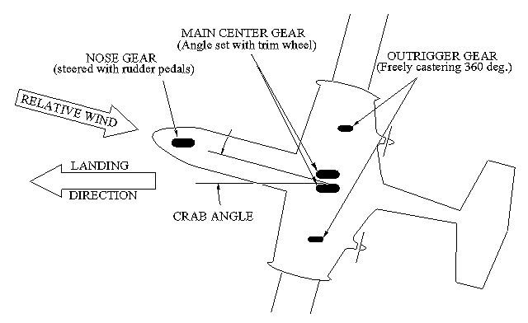
One simple gear assembly accommodates all three landing conditions, (land, water, & snow), which puts the Genesis in a class by itself as a 'triphibian'. The ruggedness of this design makes this aircraft very tolerant of rough handling in adverse conditions and harsh terrain. The increased utility, strength, & low maintenance of this patented design also increases the aircraft's inherent safety. A gear-up or a water configuration landing on hard surface only effects the reinforced, removable ski panels and the prop tips do not touch the ground.

Cockpit Controls:
Although the landing gear has several configurations - dry land, snow, intermittent snow/dry land, water, and retracted, the control is simple. A single multi-position lever is used to select the desired configuration. The configuration must be selected each time the gear is extended. This eliminates the complexity of having separate selectors for extend/retract and configuration. The pilot can visually check the position of all configurations by looking out the window over his shoulder and also by conventional position lights on the instrument panel. There is no maximum gear extend or retract speed so the gear can be used as speed brakes.
Both the nose and main gear are steerable. The nose wheel is steerable by using the rudder pedals and the main is steerable from a trim switch.

Advantages:
•The landing gear is reconfigurable in flight between water, snow, and hard surfaces - no modifications required.
•The amphibious hull is strong and absorbs energy during hard landings.
•The gear can be converted from wheels to skis and vice-versa while stationary or moving on both snow and dry surface.
•The skis can be partially lowered around the wheels to lift the wheels over intermittent snow patches, to keep tall grass from wrapping around the axles and to prevent the tires from falling into holes.
•The outrigger arms can be partially lowered to provide a stable water taxi configuration.
•The entire landing gear is extremely rugged and easily maintained.
•Landing shock loads from engine weight do not stress the wing or fuselage structure.
•A main tire, wheel, or brake failure does not compromise directional control of the aircraft during takeoff or landing.
•The steerable center gear virtually eliminates crosswind landing limitations.
•Landing and takeoff in crosswind conditions is done with coordinated controls.

TELESCOPIC WING
The optional telescopic wing is extendable/retractable in flight.
The telescopic wing is composed of a fixed center section and two extendable outer sections. An overlapping extension spar system makes this design an improvement over previous attempts at telescopic wing design. This overlapping spar system provides for a 2:1 span ratio, which has never before been attained.
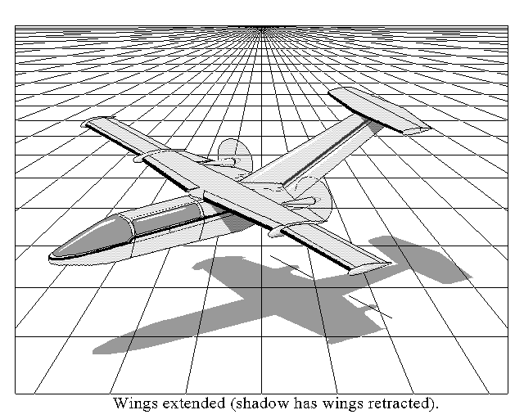
Two types of wings are available on the Genesis. One is a telescopic wing designed for high speed cruise when retracted and enhanced low speed capabilities when extended and is briefly described below. The other is a conventional wing design compromising between high performance and low landing speeds that is a fixed straight tapered wing comparable in size & design to wings used on aircraft similar in weight to the Genesis (6000 lbs maxTO).

Telescopic Wing Description:
A new approach was taken to the old concept of a variable span wing by developing (& patenting) a very simple overlapping spar system. The wing is composed of a high speed (low drag & strong) central wing section with completely retractable high lift sections which move in a spanwise direction as opposed to the chordwise direction of conventional flaps. It is the same concept of changing lift with conventional chordwise flaps except that the spanwise flap increases span & area instead of only the camber. It also increases the aspect ratio instead of decreasing it, which greatly improves efficiency and safety.
When retracted, the low drag wing reaches a cruise speed of over 280 mph @ 75% power. When extended, the stall speed is only 63 mph. The low landing speed compliments the gear's ability to land on snow and water, making this aircraft exceptionally suited for bush pilots (STOL) without compromising its performance for other applications.
During takeoff & landing the high lift airfoils are extended at the wing tips. When transitioning to a high speed cruise, they are retracted in flight to leave a high-speed low drag wing capable of withstanding high 'g' loads. This system is simple, rugged, and fail-safe. The aircraft can also maneuver in flight and land safely with the wings in any position from fully extended through fully retracted. The extension/retraction mechanism is a simple system of cables that prevents asymmetric extension. Redundancy is built in so that failure of any cable does not hinder safe operation. Ailerons are on both the center section and extendable sections and are fully functional at all times during the extension/retraction process. The airfoils are conventional NACA sections.
The mechanism is simple and reliable. The extendable section spars interlock and are guided on rollers to increase the span. Binding under load during transition is prevented by the details of the roller system. This design is actually simpler than conventional high lift devices.
The overall weight of this wing is comparable to that of a conventional compromise wing for a similar size aircraft that is required to produce the same speed range, however, it is stronger and more efficient than the conventional wing. When retracted, this wing's strength puts it in an Aerobatic category (6.0 g's), and when extended, it is in the Normal category (3.8 g's).

Comparison of conventional and telescopic wings:
This is a simplified comparison of conventional and telescopic wings to show the concepts involved. Conventional flaps and other high lift devices can be applied to both wing types with equal effects.

Weight: In order for the conventional wing to match the low stall speed of the telescopic wing, it would need a planform area and span similar to the extended telescopic wing (which is relatively large). As speed is increased, less wing area is needed to produce the required lift. So, for this conventional wing, at high speeds there is a lot more wing exposed to the high aerodynamic loads than is required. For this large conventional wing to be strong enough to reach the high cruise speeds that the retracted telescopic wing can achieve, it must be exceptionally strong, which means a heavy structure. The telescopic wing, on the other hand, has only the inboard wing section (1/2 of the span) exposed to the high aerodynamic forces in cruise, which reduces structural weight. Since retractable high lift devices such as flaps and the extendable wing sections are only used at low speeds, they do not need to withstand the high aerodynamic forces that exist at cruise speeds and they can be made lighter. Because a conventional wing is a compromise between the large low speed wing and the short high-speed wing its performance is also compromised. The telescopic wing does not compromise its performance and can reach lower stall speeds and higher cruise speeds than the conventional compromise wing. The telescopic wing, including the telescoping mechanism (rollers, cables, etc.), is actually lighter than a conventional wing that reaches the same stall and cruise speeds. A conventional compromise wing can be built slightly lighter than the telescopic wing but it would not have the low stall speed or the tremendous strength at high speeds that the telescopic wing has.

Complexity: A conventional compromise wing uses flaps and sometimes movable slats to reduce the stall speed to that of the telescopic wing. The Gevers telescopic wing actually has fewer critical moving parts than a complex fowler flap does. A component failure is less likely to occur in the telescopic wing and if it does, components are redundant and the design is also fail-safe. Redundancy means that a single component failure such as an extension cable breaking does not affect the actuation of the wing. Fail-safe means that if multiple components fail the wings will simply stop in the current position. If this occurs, the aircraft can still fly, land, and maneuver with the wings in any position. Asymmetric extension is prevented by the design more so than with some conventional flaps. So the Gevers telescopic design is simple and safe.

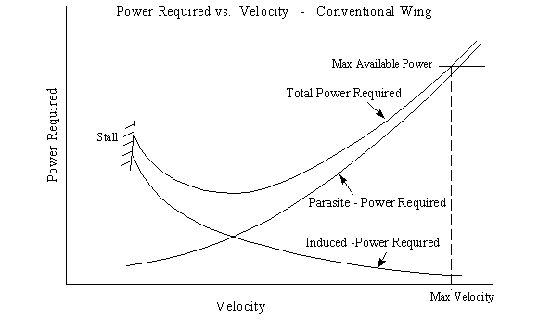
Performance: Weight and drag are the obstacles to achieving high performance. The wing drag is the sum of two components, induced drag and parasite drag. Induced drag is due to lift and parasite drag is mainly due to surface friction. Increasing the size of a wing increases its parasite drag. The first graph bellow shows how much power is required (vs. velocity) to overcome the induced, parasite, and total drag. For low speeds the majority of the drag is induced drag and at high speeds it is parasite drag. So the large wing that is beneficial for low stall speeds is detrimental at the high cruise speeds. Ideally, one would want to remove the extra wing area used at low speeds in order to reduce drag during cruise and increase speed and efficiency. This is exactly what is done with the telescopic wing. Another benefit mentioned in the weight section above is that removing the extra wing area from the high speed air allows for that section of wing to be lighter because it does not need to withstand the high speed forces. This weight reduction also improves performance. Rate of climb (ROC), range, endurance, ceiling, etc. with the wings extended are also greatly improved over a conventional compromise wing. For the telescopic wing, these improvements do not come at the expense of cruise speed as in the conventional wing. The second graph below shows the total power required vs. velocity for operation with wings extended and retracted. It shows that low speed performance benefits from the wings extended and high speed benefits from wings retracted, (less power required). For twin engine aircraft, one engine out operation (ROC especially) has a tremendous advantage with the wings extended. The difference between one engine out power available and power required (ROC) for the wings extended is about double that for the wings retracted for an aircraft like the Gevers Genesis.
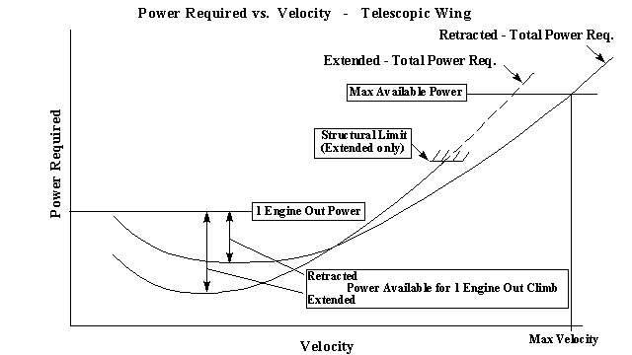
Cockpit Controls:
The wing extension control is simpler than for a normal flap. There is a single two position (Extend - Retract) switch that controls the wing position. There are no intermediate settings. The ailerons are fully functional at any point during the extension process. Instrument panel indicator lights report fully extended, fully retracted, and intermediate wing positions. Both the flaps and the wing extensions have the same maximum extend speed limitations. Airspeed sensing limit switches prevent inadvertent extension at high speeds. The appropriate flap and wing extension airspeed range is marked on the airspeed indicator.

Advantages - Wings Retracted:
•Span reduction raises wing strength to aerobatic rating.
•Small wing area improves ride quality in rough air.
•Hangar space is minimized.
•Small aileron area provides light stick forces at high speed.
•Provides protection from ice accumulation on half of the wing span until needed for landing. •Simulates high performance jet aircraft for economic pilot training.
•Can be used as test vehicle for full scale aerodynamic testing of new wing geometries on the extension sections.
•Drag reduction improves speed and efficiency.

Advantages - Wings Extended:
•Rate of climb is improved, especially during single engine operation.
•Endurance (maximum time in the air - search and rescue, surveillance) is improved.
•Range (maximum distance covered) is improved.
•Absolute and service ceilings (mountain clearance) are raised.
•Glide distance is increased and best glide speed is lowered.
•Touchdown speed is lowered.
•Takeoff and landing speeds are reduced.
•Takeoff and landing lengths are reduced (STOL capabilities).
•Landing impact energy is greatly reduced.
•Extra aileron area improves handling and control at low speed.
•Extended wings rather than high lift flaps allow the horizontal tail to operate at a low angle of attack (downwash) - better protection from ice accumulation.
INTERCONNECTED PROPELLER DRIVE
The wing mounted props are belt driven from fuselage mounted engines.
Safety is greatly improved with the Genesis. The twin engine twin propeller arrangement has both engines connected together to both propellers in such a way that during an engine failure both propellers are still powered equally by the remaining engine. As a result no action is required by the pilot to maintain directional control during an engine failure because there is no asymmetric thrust only a decrease in total power. In normal operation the propellers will be coupled together and are driven at the same RPM. However, they can be coupled and decoupled in flight from the cockpit at the pilot's discretion. Engine out rate of climb is also significantly improved with this design.
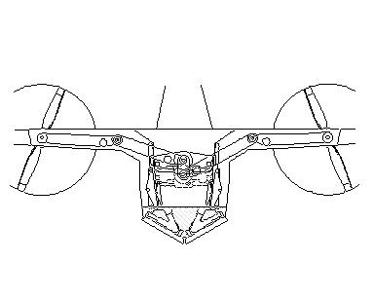
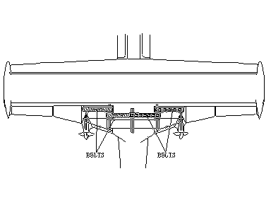
Description:
This interconnected propeller system gives the Genesis the operational ease of a single engine design with twin engine performance and greater safety than both. This is a very simple mechanical fail-safe system. Two engines are mounted facing each other in the fuselage directly above the main landing gear. They both drive into a common, simple gearbox through overrunning clutches. The gearbox drives two constant speed props through a triple set of redundant timing belts and pulleys. The 3 parallel belts in each set are separated by partitions preventing a failed belt from becoming entangled with the others. Belt drives are becoming common in new production helicopters along with experimental and FAR part 23 aircraft. This belt system is lighter and more reliable than a gearbox system because there are three belts in parallel providing a triple redundant fail safe advantage that a conventional gearbox system does not have. No power is transmitted through the gearbox unless one engine is shut down.

Belts:
The high reliability of timing belts is well known. Failures of these components occur from misalignment, contamination, and shock loads. Alignment and lack of contamination are guaranteed by this design. And if shock loads occur (prop striking an object), we want the belt to fail rather than the engine. Belts in a properly designed system will last longer than the engine overhaul time (and will be replaced at overhaul).

Overrunning clutches provide single engine simplicity with multi-engine reliability.
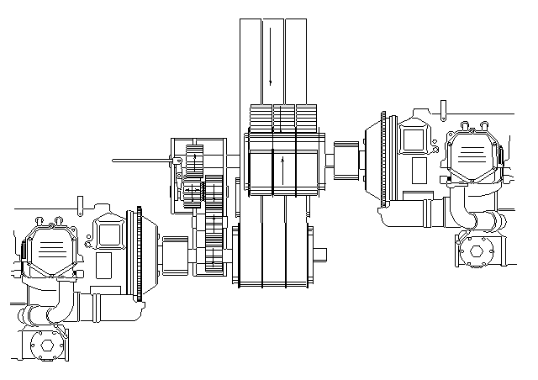
During normal operation both engines produce nearly the same power, and are geared together so they run at exactly the same RPM. The engines power a common gearbox, which in turn drives both propellers and provides automatic synchronization. There are two instances in which the engines would not operate as one.
In the first case, one engine produces so little power that it can't maintain the RPM at which the other engine is running. For example, during a catastrophic engine failure or even when one engine is at 75% power and the other is at idle. Here the overrunning clutch on the dead or idling engine allows it to "drop out" so it doesn't contribute any detrimental drag on the other engine. In fact, it can even be shut off and re-started while the other engine powers the gearbox and both propellers. One engine can suddenly loose power (and even come to a stop) and the other engine automatically assumes the load of both propellers - no asymmetric thrust. The "dead" engine does not load down the running engine.
It should be noted that one engine driving both props is more efficient (and much safer) than the conventional situation of one engine driving one propeller. Two props running at half power produce more thrust than one prop at full power. This design also avoids the asymmetric thrust which causes the aircraft to assume a dangerous high drag producing configuration.
A second situation in which the engines would not run at the same RPM is produced when the pilot elects to de-couple the props. This is done with a cockpit control that separates two gears in the gearbox. Each engine drives its respective propeller as in conventional designs. The overrunning clutches are still in the drive system.
Decoupling is required in the unlikely event of a propeller failure, in which the offending prop must be shut down. Note that in the case of a runaway prop (pitch goes to low - RPM goes out of control) the overspeeding prop cannot damage the engine by forcing it to a higher RPM. In fact the propeller speed governor located on the engine prevents engine overspeed even when the load is suddenly removed.

Internal fuselage mounted engines.
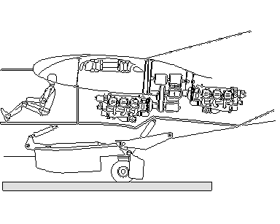
Hinged side panels in the fuselage allow for easy access to both engines for maintenance. Locating the engines above the center main landing gear is structurally beneficial because the landing forces from the engines are transmitted directly to the main gear without passing through the wing structure.
The majority of aircraft noise comes from engine exhaust and the propellers. Noise levels in the Genesis cabin are decreased because the exhaust and propellers are well behind the passengers and sound baffling can be used in the engine compartment similar to a car. Whereas a typical single engine aircraft has the prop directly infront of the cabin and the exhaust below the pilot's feet and a typical twin has both the exhaust and props right next to the passengers on both sides. So the Genesis is much quieter than conventional twin or single engine aircraft.
Eliminating the engine nacelles from the wing reduces drag and returns that section of wing to a smooth lift-generating surface.
With the engines internally mounted better temperature control for the engines is possible over the range of flight conditions from ground operation to cruise. Forced airflow through the engine compartment gives the pilot direct control of cooling when hot as well as heating in cold environments.
Placing both engines near the C.G. greatly reduces the rotational moment of inertia of the aircraft, which improves spin control and safety. The C.G. is also kept low in this arrangement improving high-speed taxi maneuvering in the water and on land.

Movable propeller arms.
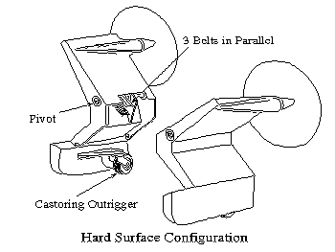
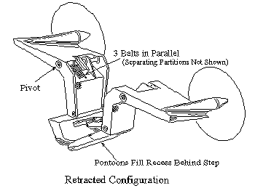
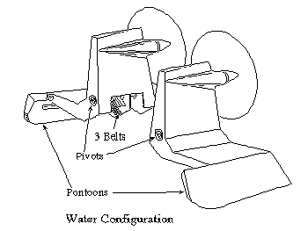
Mounting the engines internally and driving the propellers through timing belts allows for the propellers to be mounted on arms that can be rotated clear of the ground and water spray. This also eliminates the possibility of passengers and ground personnel from coming into contact with a running propeller. For cruise, the props are positioned so the thrust line matches the drag line. This eliminates the inefficiencies of a typical amphibian where the high thrust line creates a large nose down pitching moment in cruise. The propellers are mounted on the upper end of the outrigger landing gear leg. When the landing gear is extended the props automatically raise.

Cockpit Controls:
The overrunning clutches and central power gearbox allow for improvements in engine controls. The pilot no longer has to look at instruments inside the cockpit to synchronize engines during the critical takeoff period when he needs to be looking outside. There is one lever for engaging and disengaging the gearbox to connect the propellers. When engaged, both throttle and both "Prop" levers act together so operation is similar to a single engine aircraft. Power changes can be done without the need to match engines by referring to the manifold pressure gages and tachometers. When the gearbox is disengaged, the controls are identical to a conventional twin engine aircraft.
The propeller arms are part of the landing gear outriggers so they move automatically when the gear extends or retracts and the pilot does not need to actuate or monitor them separately.

Advantages:
•No asymmetric thrust from engine failure to cause extra drag and asymmetric lift.
•Little pilot action required at engine failure and no tasks required inside the cockpit - greatly enhances safety.
•More available thrust than conventional aircraft with an engine failure.
•An overspeeding propeller will not damage an engine.
•Greatly improved engine out rate of climb.
•The pilot has a greatly reduced workload during normal takeoff. He is not required to look in the cockpit for power reductions or to synchronize engines.
•Identical engines facing each other allow for counter rotating props which minimizes engine costs.
•Mounting the engines internally also provides better temperature control (cooling & heating). Forced airflow through the engine compartment can be directly controlled by the pilot in flight and on the ground. This is especially advantageous for preflight heating and post flight cooling in both hot and cold environments.
•The location of the propellers and engine exhaust behind the passengers reduces noise levels in the cabin.
•The use of timing belts and the central gear box ensure that both propellers remain at exactly the same RPM - no pilot action required to synchronize the props which allows more time for scanning of instruments or traffic.
•Pulley diameter ratios give speed reduction without using much more expensive geared engines (reduces overhaul cost).
•The engines and mounts are protected from propeller imbalance forces, which reduces wear and improves reliability.
•The propellers are protected from engine power pulses, which reduces blade fatigue & improves reliability of the props.
•The engine crankshaft is not stressed from propeller gyroscopic forces.
•Forces from a propeller striking an object do not damage the engine crankshaft.
•The sudden loss of a prop blade will not try to tear the engine off of the airframe or compromise the structure.
•Hard landings are more tolerable because landing forces due to engine weight are transferred to the main landing gear directly beneath the engines without passing through the wing structure.
•Drag reduction from absence of engine nacelles improves speed and efficiency.
•The low center of gravity due to engine location makes high speed taxiing safer on water and land. •Since the engines are not attached to the wing, engine vibrations and landing shocks do not compromise the strength of the wing structure.
•Placing both engines near the C.G. greatly reduces the rotational moment of inertia of the aircraft, which improves spin control and safety.
•During a takeoff or landing on water, the props are fully shielded from water spray (and damage) by the wing.
•Retracting the landing gear lowers the props to the center of drag eliminating the nose down trim drag of a high thrust line.
•On the ground, passengers and ground personnel are afforded greater safety since the props are above the wing.
•In the unlikely event of a prop failure simply extending the gear puts the prop thrust lines close to the centerline of the aircraft, minimizing yaw from asymmetric thrust.
•In the unlikely event of a prop blade separation, the resulting damage from vibrations will be limited to the prop arm above the wing pivot and not affect the engines, landing gear, or C.G.
•With the landing gear retracted, the outriggers fill in the hull aft of the step, forming an aerodynamically clean fuselage.
•This patented system allows the C.G. of the engines to remain low while the propellers are mounted in a manner to give protection from water spray and are clear of passengers while operating on the ground.

MODULAR FUSELAGE
Several versions of the aircraft use the same wing and fuselage components.
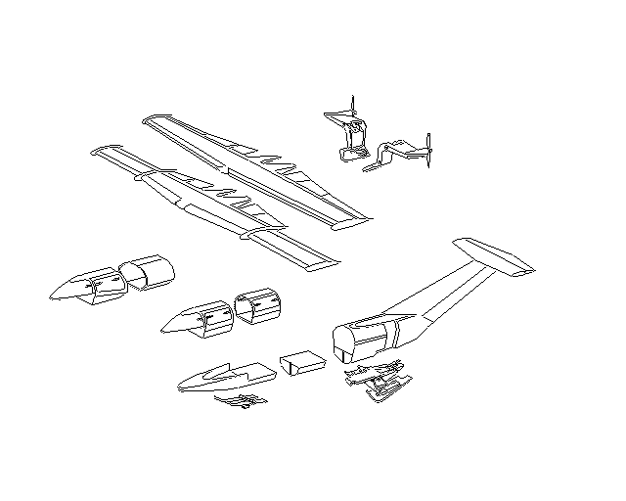
Description:
The fuselage is constructed from sections that are bolted together. Two, four, six, and eight passenger aircraft can be made from all the same components except the passenger compartment. The longer aircraft has larger engines that counter balance the higher fuselage weight. The figure above shows the individual subassemblies with the standard and wide body (cargo) cabin and both the conventional and telescopic wing types.

Advantages:
•Production costs, selling price, maintenance costs, and spare parts costs are minimized since the number of different components for all of the aircraft models is low.
•Production inventory and spare parts inventory are minimized.
•Dismantling, shipping, and re-assembly are simple and efficient.
•Major repair of the main structure is simplified.

SIMPLICITY OF OPERATION
Designed to be as simple as a single engine airplane to operate.
Control system design innovations in the Genesis aircraft make the pilot duties simple and straightforward even though the aircraft performs functions never before possible.
Wing Extension Control:
The wing extension is simpler than normal flap operation. There is a two position (Extend - Retract) switch that controls the wing position. There are no intermediate positions, although the ailerons are fully functional at any point during the wing extension. Fully extended, fully retracted, and intermediate positions are reported by instrument panel indicator lights. Both the flaps and the wing extensions have the same maximum extend speed limitations. Airspeed sensing limit switches prevent inadvertent extension at high speeds. The appropriate flap and wing extension airspeed range is marked on the airspeed indicator.
Landing Gear Position Control:
Although the landing gear has several configurations - dry land, snow, intermittent snow and dry land, water, and retracted, the control is simple. A single multi-position lever is used to select the desired configuration. The desired configuration must be selected each time the gear is extended. This eliminates the complexity of having separate selectors for extend/retract and configuration.
All configurations can be visually checked by the pilot by looking out the window over his shoulder. Additionally, there are the conventional position lights. There is no maximum gear extend or retract speed so the gear can be used as speed brakes.
Engine and Propeller Controls:
The overrunning clutches and central power gearbox allow for great improvements in engine controls. The pilot no longer has to look inside the cockpit to synchronize engines during the critical takeoff period when he needs to be looking outside.
Power reductions during takeoff are made by first pulling both power levers back to a preset (but adjustable) stop. "Prop" levers are then likewise pulled back together to a stop. These power reductions can be done without referring to the manifold pressure gages and tachometers.
Main Gear Steering Control:
In a conventional aircraft, during crosswind conditions, the pilot has to make a dangerous last minute cross controlled maneuver immediately before touch down at or near stall speed. In high winds this maneuver requires considerable pilot skill.
In the same situation the Genesis pilot simply trims the center gear steering at some point during the landing approach, then lands in a level and coordinated condition. No cross controlled maneuvers are ever required. The rudder is used only for taxiing.
The control is a conventional electric trim switch similar to pitch and rudder trim, with a manual trim wheel for backup. There is a position indicator that shows the degree of center gear trim in effect that can be visually compared to the angle of crab of the aircraft during final approach.
The trimable center gear can also be used during takeoff. The position returns to center when the gear is retracted so it cannot be inadvertently left at the wrong angle for the next landing.
Advantages:
•Greatly enhanced takeoff safety by not requiring the pilot to synchronize engines or take his visual attention from outside the aircraft.
•Unparalleled improvement in safety during engine failure, requiring very little pilot attention or ability.
•Elimination of the need for conventional crosswind landing technique.
•Gear position can be verified visually
AERODYNAMICS
The mechanical innovations lead to aerodynamic advantages.
Description:
Telescopic Wing:
The telescopic wing is an alternative to sophisticated high lift devices (e.g. slotted fowler flaps). In operation, it is treated like a "span flap" rather a conventional "chord flap". It is used at only low speeds and has a maximum speed limit just as a convention flap.
Swept Tail:
The swept tail is a result of connecting the horizontal stabilizer to the back of the fuselage using the straightest, most direct, structure. This is done rather than extending the fuselage horizontally and attaching the tail on top of it.
The vertical tail volume (area times moment arm) is generous, although visually deceiving. The height of the rudder is typical of "T" tail configurations so that the roll couple is reasonable.
Inboard Engines:
Since the engines are mounted inboard and the propellers are driven by belts, there are no engine nacelles. The only disturbance to the airflow is the small bump on the trailing edge of the wing required to house the belt pulley.

Advantages:
•Telescopic Wing
•High lift at low speeds without the drag penalty of flaps.
•Increased aspect ratio at low speeds which improves efficiency - unlike conventional flaps.
•The retracted configuration has much higher stiffness and resistance to bending and twist (i.e. flutter resistant) than a conventional wing.
•The retractable wing is lighter than a conventional wing with the same stall speed, and maximum speed, and strength requirements
•Swept Tail
•The straight line from the fuselage to the tail provides the most rigid structure possible, to combat high speed flutter.
•The tail design is structurally most efficient by attaching directly to the strongest part of the aircraft.
•The sweep of the tail provides generous ground clearance for high angle of attack takeoffs and landings.
•The lower part of the rudder contributes to yaw control force which lowers the vertical rudder volume (area times moment) minimizing roll resulting from rudder application ("roll coupling").
•The aft swept rudder hinge line provides beneficial pitch up moment from rudder application to counteract the usual pitch down tendency.
•Inboard Engines
•There are no engine nacelles to detract from maximum lift by disrupting the airflow across the wing.
•There are no engine nacelles to create drag.
•The airflow through the propellers is not disturbed by large engine nacelles.
DESIGN VERIFICATION
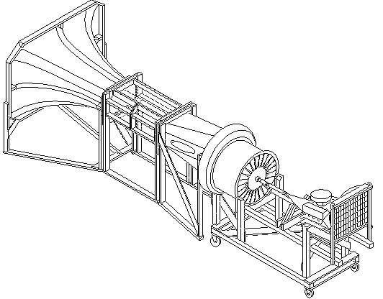
Latest technology analysis and verification.

Stability Verification:
The static and dynamic stability of the design has been verified using a computer simulation based on an extensive wind tunnel study done by the United States Air Force and McDonnell Douglas Corp. This study, called the USAF Stability and Control Datcom (DATa COMpendium), is a four volume (3,000 pages) summary of wind tunnel tests performed for the purpose of providing stability derivatives and aerodynamic forces for analytical modeling of aircraft.
Over a period of three years a unique computer program was written which uses the DATCOM results for the sole purpose of verifying and optimizing the stability of the Genesis design. Other aircraft were modeled as a check of the accuracy of the program.
This study shows that the Genesis design has desirable characteristics in all measures of stability and control in both the wings retracted, and extended configurations, and with the gear in all positions. The controllability with an engine inoperative is a particularly significant improvement over conventional designs. The structurally efficient swept "T" tail shows excellent rudder control down through stall speed - no VMC speed. Rudder induced roll coupling is minimal.

Performance Verification:
The performance figures were verified using computer programs based on standard analytical methods found in widely used design texts. The accuracy of these programs were checked by modelling common production aircraft and verifying the performance data.

Wind Tunnels:
A small wind tunnel was built (see the May 1994 issue of the EAA Experimenter Magazine) as an aid to flow visualization in the early stages of the design. In particular interactions between fuselage, wings, propeller arms, gear legs, and swept tail were of interest. The small tunnel is an open circuit (non-recirculating) type, 26 feet long overall and powered by a 200 HP internal combustion engine. The laminar velocity profile across the 19 inch high by 27 inch wide test section is exceptionally consistent.
A larger wind tunnel with a 5’ x 7’ test section was also built to examine stability & control characteristics. This tunnel has a fully automated 6 component scales and is capable of producing 200 mph airflow in the test section.

Finite Element Model:
Many aspects of the design are being simulated using a finite element analysis computer program. This analysis is more sophisticated and complete than was used on the current general aviation light aircraft at the time they were designed.

Flying Model:
A 1/5th scale flying model was built and flown to verify specific aerodynamic considerations (primarily low speed rudder effectiveness) and to visualize component interactions.

The flying model, wind tunnel tests, and various computer programs are in agreement and are the basis for the preliminary performance figures.
SPECIFICATIONS
Unprecedented safety, utility, and performance.
•DIMENSIONS EXTERNAL:
•Wing span extended.............15.24 m (50 ft 0 in)
•Wing span retracted...............7.87 m (26 ft 0 in)
•Wing chord at fixed root........3.25 m (10 ft 8 in)
•at fixed tip..................…..2.03 m (6 ft 8 in)
•at extension root....…...….1.12 m (3 ft 8 in)
•at extension tip..........…..1.12 m (3 ft 8 in)
•Wing aspect ratio extended.....8.33
•Wing aspect ratio retracted.....3.1
•Length overall.......................11.58 m (38 ft 0 in)
•Height overall.........................3.75 m (12 ft 4 in)
•Tailplane span.........................4.44 m (14 ft 7 in)
•Wheel track.............................3.2 m (10 ft 6 in)
•Wheelbase...............................6.35 m (18 ft 6 in)
•Propeller diameter..................1.98 m (6 ft 6 in)
•Passenger door:
•Height.............................0.97 m (3 ft 2 in)
•Width..............................2.24 m (7 ft 4 in)

•DIMENSIONS INTERNAL:
•Cabin:
•Length.............................3.05 m (10 ft 0 in)
•Max width.......................1.21 m (3 ft 11-1/2 in)
•Max height......................1.07 m (3 ft 6 in)
•Volume...........................3.74 cu.m (132 cuft)
•Nose baggage.....................0.283 cu.m (10 cuft)
•Rear baggage......................0.425 cu.m (15 cuft)

•AREAS:
•Wing extended, gross...........................28.60 sqm (308 sqft)
•Wing retracted, gross...........................20.40 sqm (220 sqft)
•Ailerons ret. (total)................................1.16 sqm (12.5 sqft)
•Ailerons ext. (total)...............................2.79 sqm (30 sqft)
•Trailing edge flaps (tot.)........................0.71 sqm (7.67 sqft)
•Vertical stabilizer (not incl. rudder)......4.16 sqm (44.8 sqft)
•Rudder, incl. tab.....................................1.39 sqm (15 sqft)
•Horizontal stabilizer...............................3.81 sqm (41 sqft)
•Elevator incl. tab....................................1.90 sqm (20.5 sqft)

•WEIGHTS:
•Empty weight.........................................1540 kg (3600 lb)
•Max T O weight.....................................2720 kg (6000 lb)
•Max wing loading ext..............................95.1 kg/sqm (19.5 lb/sqft)
•Max wing loading ret..............................133. kg/sqm (27.3 lb/sqft)
•Max power loading.................................5.61 kg/kW (9.23 lb/hp)

•PERFORMANCE:
•Max level speed at max weight of 2720 kg (6000 lb)......... 267 kt (496 km/h; 308 mph)
•Cruise speed at max weight of 2720 kg (6000 lb) at S/L, wings retracted
•75% power..................................................................225 kt (450 km/h; 280 mph)
•65% power..................................................................214 kt (435 km/h; 270 mph)
•one engine inop...........................................................192 kt (386 km/h; 240 mph)
•Stall speed:
•flaps, gear, wings retracted...........................................95 kt (175 km/h; 109 mph)
•flaps, gear, wings extended...........................................55 kt (101 km/h; 63 mph)
•Rotation speed.....................................................................66 kt (122 km/h; 76 mph)
•Approach speed...................................................................71 kt (132 km/h; 82 mph)
•T O run:
•on hard surface............................................................220 m (720 ft)
•on water.......................................................................305 m (1000 ft)
•T O to 50 ft:
•on hard surface............................................................495 m (1625 ft)
•on water.......................................................................581 m (1905 ft)
•Landing from 50 ft:
•on hard surface............................................................600 m (1970 ft)
•on water.......................................................................683 m (2240 ft)
•Landing run:
•on hard surface..............................................................70 m (230 ft)
•on water.......................................................................152 m (500 ft)
•Range with max fuel (200 gal).......................................1,910 nm(3540 km; 2,200 miles)
COMPARISON TO THE COMPETITION
The Genesis performance stands far ahead of all other designs.
Description:
The following graphs show the Genesis six place model in relation to the aircraft found in the 1993/94 Jane's All The World's Aircraft and the 1993 Aviation Week business aviation index.
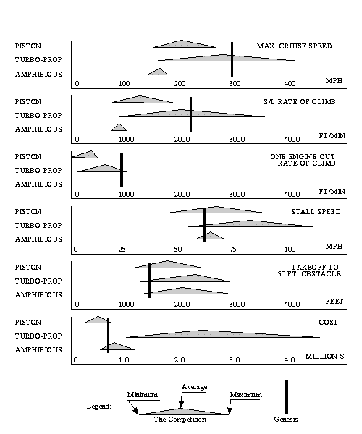
Maximum Cruise Speed:
The Genesis outperforms other piston powered aircraft and is far more efficient than any other amphibious aircraft. In addition, it holds a respectable place among turboprop powered aircraft. This superior performance is due mostly to low drag from the innovative landing gear and wing retraction capability and the absence of engine nacelles due to inboard engines.

Rate of Climb:
The long aspect ratio wings used during takeoff and landing gives the Genesis excellent rate of climb (ROC). In addition, the absence of asymmetric thrust and asymmetric drag with one engine inoperative gives unparalleled ROC in this situation.

Stall Speed and Takeoff Distance:
Generous wing area and span give the Genesis a wide margin of safety in takeoff configurations. Since the kinetic energy that must be dissipated during the landing is proportional to the landing speed squared, then the low stall speed greatly shortens the runway (and waterway) length requirements.

Cost:
The projected cost of the Genesis is attractively low. Without the need for turboprop or geared engines, the major contributor to the selling price (the engines) can be kept low. And in the case of twin engine aircraft this can save up to half of the cost of the airplane.
The internal mounting of the engines helps raise the strength and lower the cost of this design over the typical amphibious aircraft.
The greatest cost savings come from the modular fuselage design. Different engine sizes and weights offset different fuselage lengths, so all versions of the airplane use nearly all the same components. The manufacturing cost "learning curve" should level off early and at a low level.
SAFETY
Numerous innovations make this the safest aircraft ever built.
Telescopic Wings:
•The extended wing lowers the stall speed, takeoff distance, landing distance, landing energy, glide angle, and increases the climb rate, climb angle, ceiling, glide distance, range, and endurance.
•The retracted wing (in cruise) is much stronger than conventional designs.
•Short wing and high wing loading improves tolerance to gust loads and improves ride quality.
•In cruise, the outer half of the wing is protected from ice accumulation and is exposed only for landing.

Landing Gear:
•Takeoff and landing crosswind limitations are nearly eliminated.
•There is no maximum gear extend or retract speed.
•The main gear is on the aircraft centerline so that any component failure does not cause directional control problems.
•The pilot can see the gear and determine configuration and condition from his seat.
•A gear-up or a water configuration landing on hard surface only effects the reinforced, removable ski panels. Prop tips do not touch the ground.
•A water configuration landing on snow does no damage.
•A gear-up landing on water or snow does no damage.
•A ski-down landing attempt on hard surface or water gives the pilot a warning in time to abort. And if he continues, the damage is minimal.
•The landing gear is attached to the engine mounts, so the main landing shock loads do not transfer through wing spars or fuselage.

Engine and Prop. Mounts, and Drive System:
•Both props automatically provide equal thrust in the event of an engine failure.
•The pilot has a greatly reduced work load during takeoff. He is not required to look in the cockpit for power reductions.
•The rotational inertia is lower than conventional twin engine aircraft.
•The engines are easily temperature controlled on the ground and in the air.
•The engines are isolated from out of balance forces, gyroscopic forces, and object strike forces of the props.
•The props are isolated from power pulses of the engines.
•An overspeeding prop does not overspeed the engine.
•Bystanders and passengers are protected from the props during ground operations.
•In the event of a prop failure, the prop thrust lines can be brought close together to minimize asymmetric thrust.
•The low CG due to the internal fuselage mounted engines improves the safety of high speed taxi turns - on land, snow, and water.
•More available thrust than conventional aircraft during engine failure.
•Little pilot action is required after an engine failure, and no tasks inside the cockpit.
RELIABILITY
Redundancy has been designed in so that critical components are minimized.
The most common critical failure modes in light general aviation aircraft have been eliminated in this design. In some systems, the Genesis has slightly more total components than the conventional design, but in all cases the number of critical components has been drastically reduced if not totally eliminated. The most common critical components are discussed below:

Landing Gear:
•Landing gear components on the Genesis are not considered critical since the main gear is on the centerline of the aircraft. Failure of these components do not cause immediate and violent loss of directional control as does either of the two main gear on a conventional aircraft. The outriggers are only for maintaining the aircraft in a level attitude (side to side) at taxi speeds. Failure of either outrigger does not constitute a directional stability hazard.
Drive Train:
•Engine components are not considered critical in the Genesis design since the overrunning clutches and gearbox allow the "good" engine to automatically power both propellers.
•The clutches are not critical since their failure modes are to either lock in the engaged condition or to slip, neither of which constitute a directional stability problem.
•The gearbox components are not critical since they are not in use during normal operation. No power is transmitted through the gearbox gears unless an engine is shut down.
•Engine mounts are not critical in the Genesis design since the engines are in the fuselage and do not support the propellers. The drive pulleys are supported by their own bearings. The Genesis engine mounts are not likely to fail since prop imbalance does not fatigue the mounts as in conventional designs.
•The propeller blades are not critical since a serious imbalance (loss of a blade) would separate the propeller mount arm at a design break point, thereby allowing the damaged prop to be thrown free and not take an engine with it.
•The drive belts are not critical since there are three belts in parallel between each set of pulleys. Any drive belt can fail and the other two in the set are capable of handling the load. The three belts in any set are separated by partitions which prevent a failed belt from becoming entangled with any other belt.
•The high reliability of drive belts is well known. Failures of these components occur from misalignment, contamination, and shock loads. Alignment and lack of contamination are guaranteed by our design. And if shock loads occur (prop striking an object), we want the belt to fail rather than the engine. Belts in a properly designed system will last longer than the engine overhaul time (and will be replaced at overhaul).
Wings:
•The wing extension system is redundantly actuated and has no critical components other than the structure itself, which in cruise, is much stronger than conventional designs . The extension/retraction mechanism is a simple system of cables. Redundancy is built in so that failure of any cable does not hinder safe operation.
•The extension ailerons are always actuated in unison with the fixed wing ailerons, whether extended, retracted, or in transition. The actuation is also a simple cable system. The aircraft can be taken off and landed with the wings extended, retracted, or partially extended.
THE MARKET
The high utility nature of the Genesis allows for a broad market.
The Gevers Genesis will be the only aircraft ever produced in which a single plane can fulfill the requirements of all of the following categories simultaneously without modification. In addition, it will perform exceptionally well in each. For this aircraft, unlike the competition, gaining versatility in one area does not limit its performance in the other areas. In fact, the design features which give the Genesis its versatility also increase its performance above the competition's.

Bush plane
Short take offs and landings to unimproved runways on sod, water, and snow covered areas. Obviously requires STOL performance, but also requires ruggedness with maintenance materials and techniques which can be performed in the "bush". In addition, long range and high cruise speeds are desirable to travel great distances into undeveloped areas and return quickly without the need to refuel.

Seaplane
Amphibious with good water handling abilities. Stable in the water for recreational activities such as fishing. Highly economical to operate for recreational purposes. Also not restricted to water bases, able to commute between water, dry land, and snow covered airstrips without modification to the landing gear.

Personal / Pleasure
Recreational flying, travel to distances too far to drive, and sight seeing. Requires an aircraft which is simple and economical to operate and is perceived safe. Ability to personalize the aircraft in unique ways such as tail art. High resale value due to versatility and durability.

Executive / Business
Short and long trips taken at unscheduled times by company pilots generally to areas not serviced by the airlines. Requires comfortable aircraft with high cruise speed.

Flight Training
For beginners, many short training flights, sometimes handled roughly. Requires durable, simple to operate, stable, easily maintained aircraft with good visibility for collision avoidance, and low landing speeds.
For advanced training, single or multi-engine operation, retractable gear, high performance, instrument cross country training, and is safe in the most adverse training conditions (e.g. one engine inoperative and cross wind takeoffs and landings). Amphibious & ski landing gear allow for seaplane & snow landing training.

Search and Rescue
High speed cruise to the site then maximized loiter time until return or Short Take Off and Landing (STOL) performance to drop off supplies or return with passengers. Requires high cruise performance with short take off and landing capabilities. Also requires fuel efficient loiter mode with good downward visibility. The ability to land in a variety of terrain (water, land, & snow) is highly beneficial.

Air Cargo
Transport of bagged and/or palletized material. Requires maximum cabin volume and durable floor and walls. The aircraft should have a comfortable performance safety margin at gross weight. Long range and efficiency are also desirable. Occasionally carrying cargo to remote areas with a variety of terrain for landing.

Aerobatic
Requires a high degree of maneuverability, strength capable of achieving high 'g' loads, and high speeds.

Aerial Photography
High speed cruise to the site then mild maneuvers and high speed cruise return. Requires good downward visibility from cabin, good performance, stable flight when pilot is distracted, and high wing loading for smooth camera platform.
FREQUENTLY ASKED QUESTIONS
We welcome and encourage responses, (comments and questions), concerning the information presented here. Contact Gevers Aircraft by e-mail at <geversair@iquest.net>
Or write to:
Gevers Aircraft, Inc.
PO Box 430
Brownsburg, Indiana 46112 USA

Some of the most commonly asked questions are:

Q: What is the reliability of the belts in the propeller drive?
A: Belts of this type have been used for many years in machinery having much harsher environments, (i.e. higher loads, dirtier surroundings, little or no maintenance, etc.), and have been proven to be very effective and reliable. In addition, this is a redundant system consisting of 3 sets of belts in each segment, any 2 of which can carry the maximum power required.

Q: Can the aircraft be landed safely with the wings retracted?
A: Yes. Not only can the aircraft be safely landed in the fully retracted wing configuration, but it is intended to be taken off and landed in the wings retracted configuration in flight training to simulate high performance aircraft. Think of the extended wing as nothing more than span-wise flaps as opposed to conventional chord-wise flaps. Normal landings are intended to be conducted with wings extended, however, as with other aircraft, safe landings can be performed with flaps retracted. With the wings retracted stall speed is just over 100 MPH, the retracted configuration landing will be typical of a conventional high performance twin. In addition, the aircraft can maneuver and land safely with the wings in any position including transition between extended and retracted.

Q: Is there enough aileron power to handle a failed prop in "short-wing" configuration?
A: The short wing has a large aileron-to-wing area ratio, and therefore, sufficient aileron control. Although there is sufficient aileron control in the short wing configuration it would be appropriate to detail the further aerodynamic benefits resulting from our design elements in the event of a prop failure.
* Simply lowering the landing gear brings the prop centerlines close to the center of the aircraft.
* Counter-rotating props reduces asymmetric thrust.
* With the gear/prop arm retracted the props are nearly centered on the wing trailing edge. The angle of attack of the prop remains nearly constant, therefore the thrust line does not shift toward the down going blade (P-factor) because the wing forces the airflow through the prop at a constant angle.

Q: Does the aft engine & forward passenger design pose a C.G. problem?
A: No. The passenger loading is typical of conventional aft-engine designs. The center of gravity envelope will accommodate occupancy by either a single pilot or the full compliment of passengers and baggage.

Q: How do you accommodate the very high propeller shaft bending moments due to changes in angle of attack and sideslip, created by the large gyroscopic forces in maneuvers?
A: The prop arm is designed as a rigid box structure. It is relatively short (spanwise) and deep (chordwise) and is quite strong in torsion due to the triangular cross-section (taken in a plane parallel to the wing ribs). The arms are stronger than typical engine mounts on aerobatic aircraft, which have to resist not only gyroscopic forces but also landing impact loads of the engines.

Q: The pictures don't show a step in the hull bottom for water operations.
A: The aircraft does have a conventional step for water operation even though the pictures do not show its details. With the gear retracted, the outriggers are stowed in the recess in the aft bottom of the fuselage behind the step filling it in to provide an aerodynamically clean hull in cruise. When the outriggers are extended, that recess becomes the ventilated area behind the step. The step is the heel of the main center gear skis when they are retracted and as such provide a shock absorbing nature to the step. Note that in the water configuration the outriggers are fully extended while the main center gear and skis remain retracted.

Q: Doesn't the thick vertical fin produce extra drag?
A: The significant strength and stiffness improvement of this tail boom design allows for a weight reduction over conventional tail booms which more than compensates for the few pounds of added drag which have been calculated.

Q: Does the propeller drive system require specialized pilot training?
A: No. In fact, pilot training will be easier in the Genesis. All seaplanes have the propellers mounted high to keep them clear of the water spray. When increasing from idle to full power the conventional high engine mounting produces a change in pitching moment that is greater and more sudden than that for the Genesis when moving the propellers from low to high positions. So no more pilot training is needed than for any other amphibian. We should have less pitch change than a typical amphibious aircraft since the prop wash downloads the "T" tail. The pitch down tendency due to a high thrust line is offset by the added down wash across the horizontal tail. One of the most difficult and dangerous situations for a twin engine pilot is when one engine fails on takeoff. In this situation the Genesis' interconnected engines vastly reduces the workload on the pilot in the emergency situation. Props are only de-coupled for taxi operation.

Q: Is a computer controlled system required to provide gain/trim changes for stability and control in each configuration?
A: No.
The Landing gear drag is approximately balanced above and below the wing - thus little pitch change.
The wing pitching moments are approximately balanced (inboard vs. outboard wing) - thus little pitch change.
The prop wash downloads the tail - thus approximately balancing nose down thrust with tail down inverse lift.
CONCLUSION
Only innovation can revitalize General Aviation.

Mission Statement:
Gevers Aircraft, Inc. is committed to rejuvenating General Aviation through a new series of aircraft which are ingeniously innovative in design, and boldly aggressive in performance and utility goals. All aspects of these designs will provide the most inherently safe aircraft ever built.

Design Goals:
•Safety - Eliminate the current major contributors to aircraft accidents.
•User Friendly - Simple to operate.
•Modular - 2 place to 8 place with mostly interchangeable assemblies.
•Utility -Hard surface, water, and snow take off and landing capability.
•Performance - Competitive with conventional light twins.
•Cost - Affordable for the customer and profitable for the manufacturer.
•Maintenance - Easy, cheap, and "low tech." repairability and maintenance.
•Certification - Manufacturing processes to be stable, accurate, traceable, easily monitored, and continuously evaluated.

Design Philosophy:
The design was undertaken with the attitude that, initially, all goals were to be completely met., regardless of the cost and complexity. After a design took shape, the various capabilities were to be evaluated against the disadvantages. The worth while aspects were to be kept and less worthy aspects were to be discarded for the final version.

Design Synergy:
What emerged from the design, guided by the above philosophy, was a surprise. All of these, apparently conflicting goals were accomplished through an incredible synergy that exists between various aspects of the aircraft. This design is the result of a lengthy refinement of that synergy. The various systems and components of the aircraft, not only work smoothly together, but actually enhance each other. Furthermore, this synergy extends past the operation of the aircraft into the manufacturing, maintenance, and repair of the aircraft. We have thus reached design goals never before attempted with surprisingly few compromises.

The Future:
Gevers Aircraft Inc. will build a proof-of-concept aircraft, followed by a refined prototype. The ultimate goal is for production certification under Federal Aviation Regulation Part 23. The schedule for the plan is dependant upon the level of investor participation.

"IF WE ARE TO ACHIEVE RESULTS NEVER BEFORE ACCOMPLISHED... WE MUST EXPECT TO EMPLOY METHODS NEVER BEFORE ATTEMPTED." - FRANCIS BACON -

